READING
SKILL 1 : UNDERSTANDING MAIN IDEA
Didalam TOEFL khususnya reading ada akan diminta untuk mencari IDE POKOK dari sebuah teks atau paragraph. Pertanyaan berupa topik, judul, dan ide pokok akan selalu di tanyakan. Karena Text didalam TOEFL di susun secara terorganisir maka relatif ”mudah” mencari jawabannya yaitu dengan mencari topic sentence yang biasanya dapat dilihat di awal setiap paragraph. Apabila jumlah paragraphnya lebih dari satu maka anda harus memahami topic sentence di setiap paragraph tersebut. Contoh :
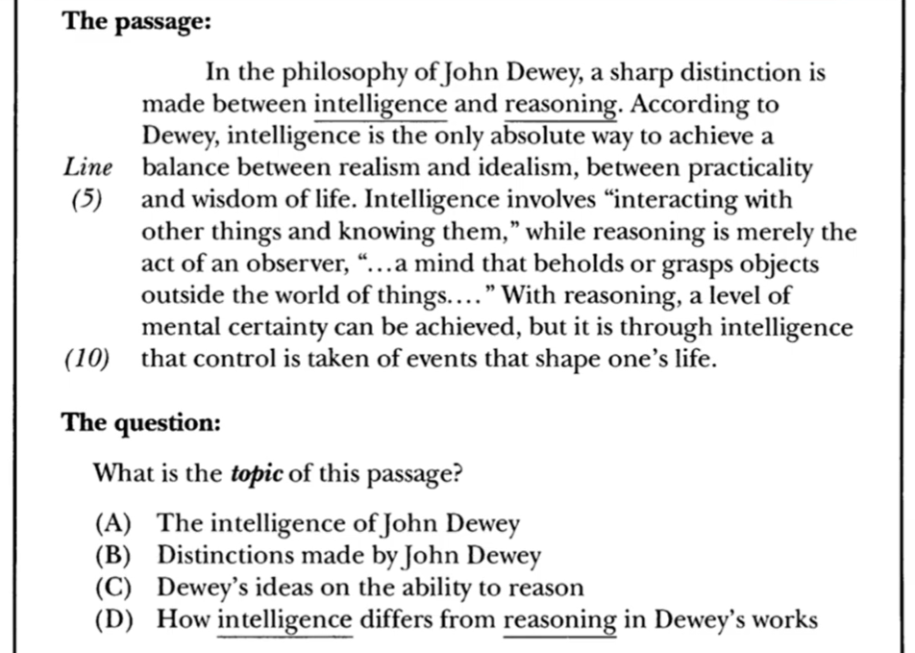

Contoh apabila paragraph lebih dari satu :
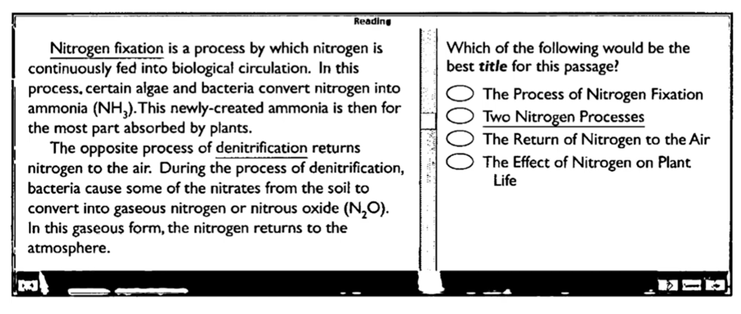

Kesimpulan
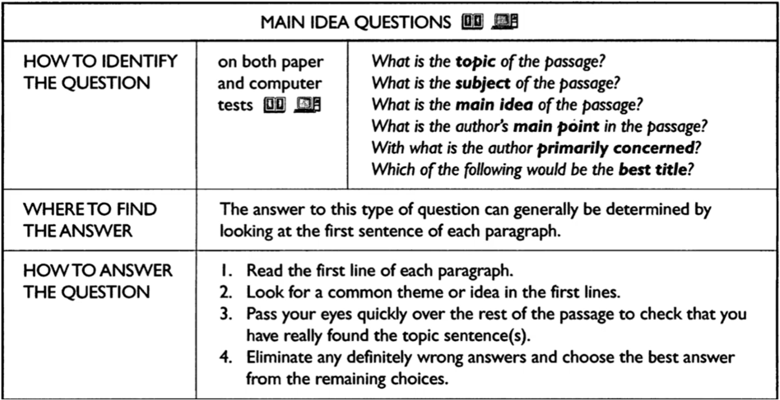
Exercise
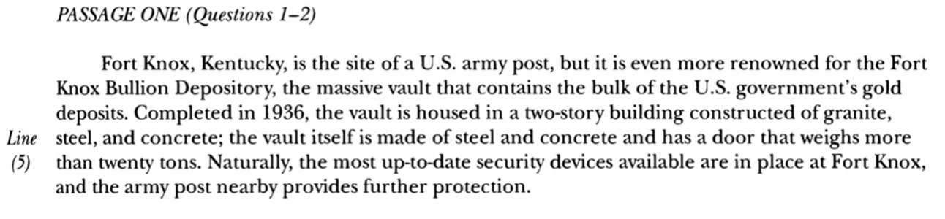
- Which of the following best describes the topic of the passage?
- The city of Fort Knox, Kentucky
- The federal gold depository
- The U.S army post at Fort Knox
- Gold bullion
- Which of the following would be the best title for this passage?
- The Massive concrete Vault
- Fort Knox Security
- Where the United States Keeps Its Gold
- A Visit to Kentucky
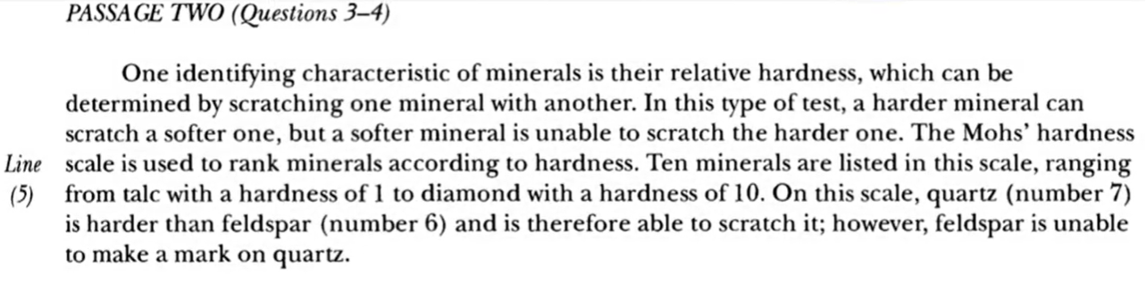
- Which of the following best states the subject of this passage?
- The hardness of diamonds
- Identifying minerals by means of a scratch test
- Feldspar on the Mohs’ Scale
- Recognizing minerals in their natural state
- The main idea of this passage is that?
- The hardness of a mineral can be determined by its ability to make a mark on other minerals
- Diamonds, with a hardness of 10 on the Mohs’ scale, can scratch all other minerals
- A softer mineral cannot be scratched by a harder mineral
- Talc is the first mineral listed on the Mohs’ scale
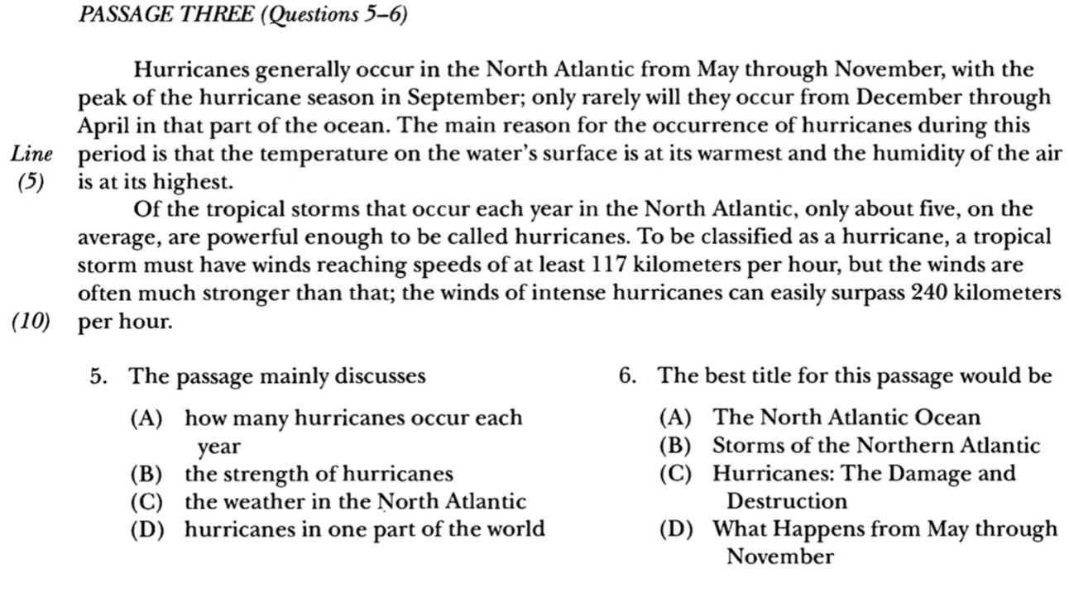
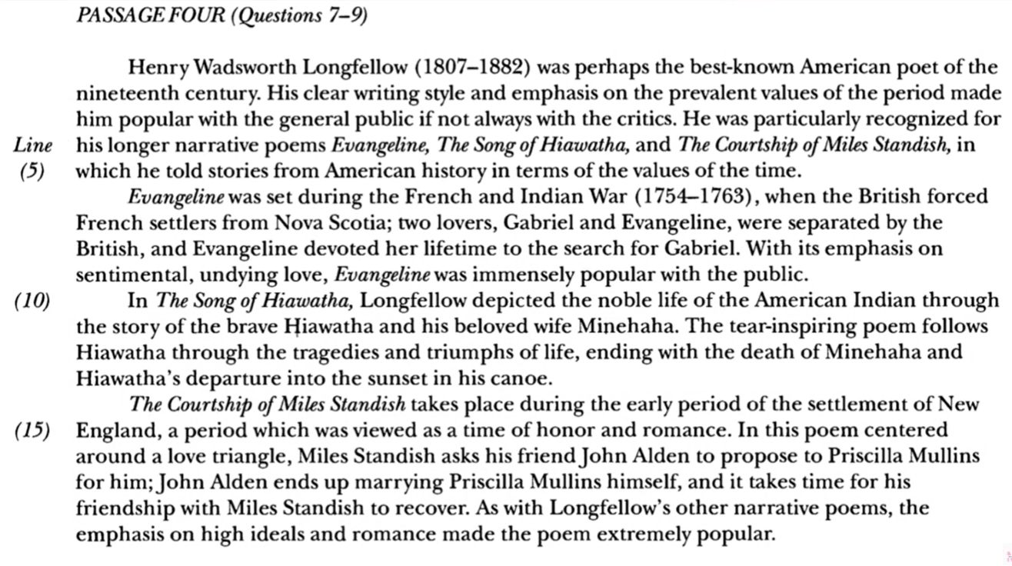
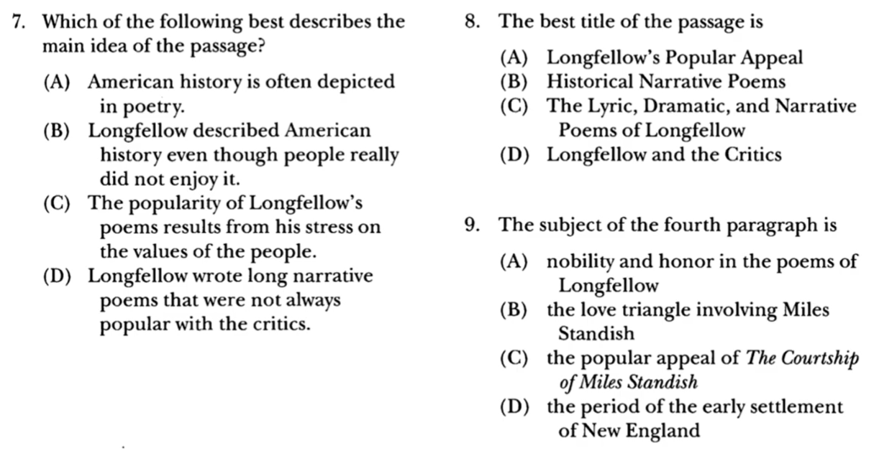

SKILL 2 : RECOGNIZE THE ORGANIZATION OF IDEAS
Didalam test reading TOEFL seringkali kita jumpai pertanyaan yang menanyakan organisasi terkait text, dalam hal ini bagaimana teks itu disusun. Contohnya adalah anda akan diminta untuk menentukan bagaimana paragraph yang satu dengan yang lainnya saling terhubung. Contoh
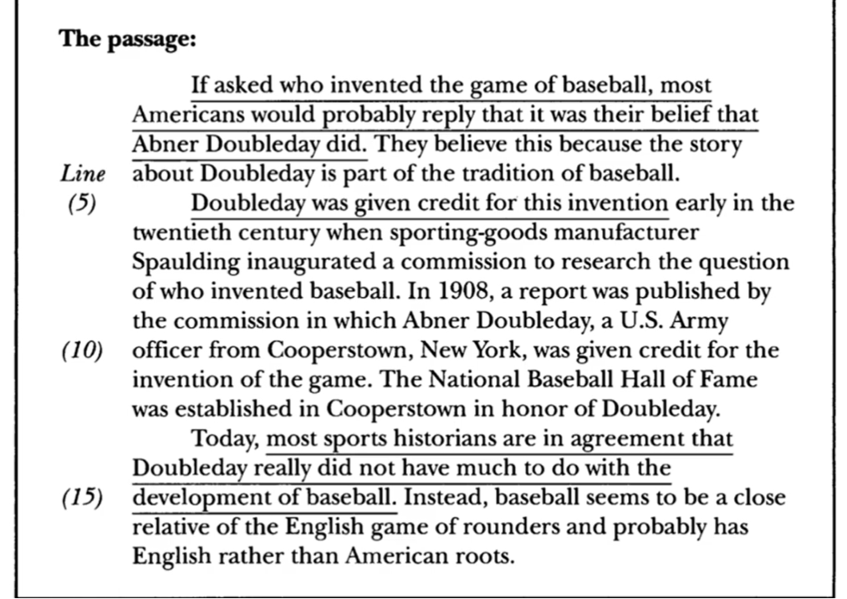
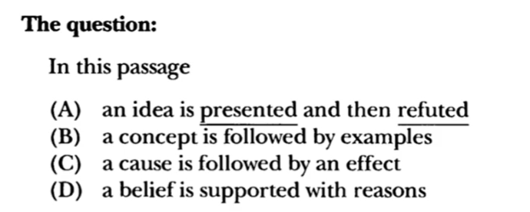
Kesimpulan
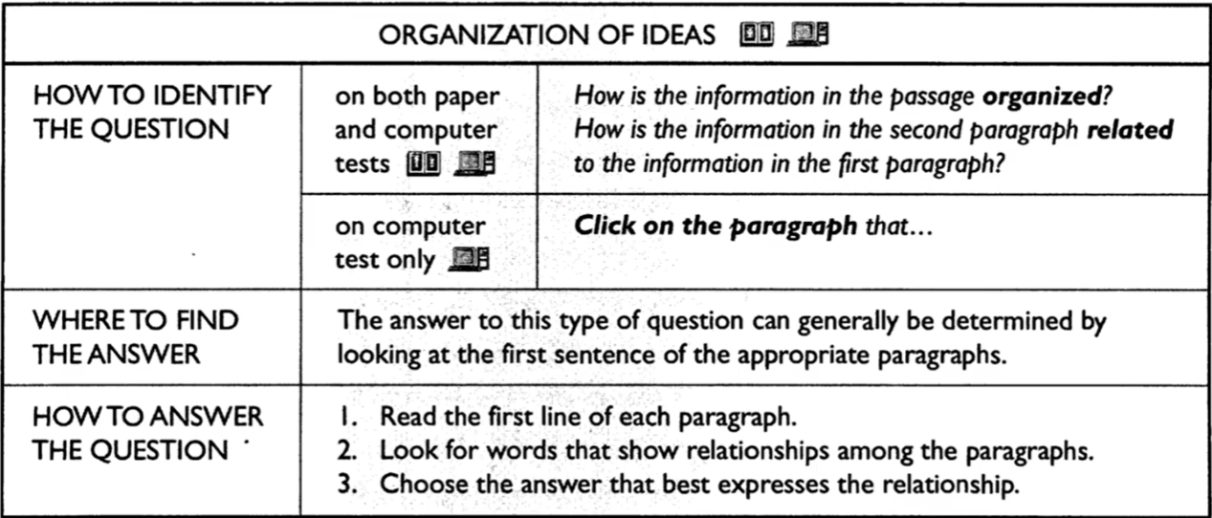

Latihan
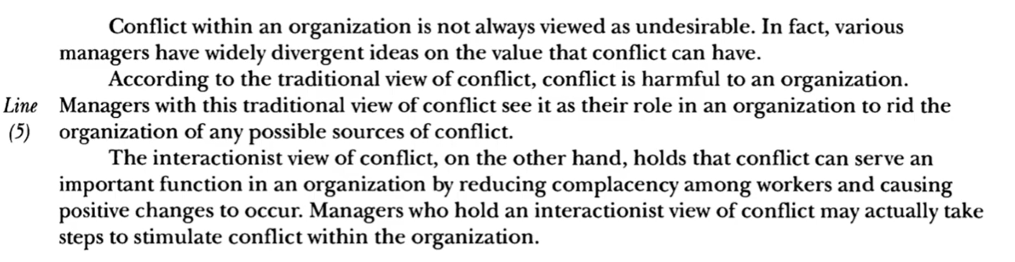
- How is the information in the passage organized?
- The origin of ideas about the conflict is presented
- Contrasting views of conflicts are presented
- Two theorists discuss the strengths and weakness of their views on conflict
- Examples of conflict within the organizations are presented
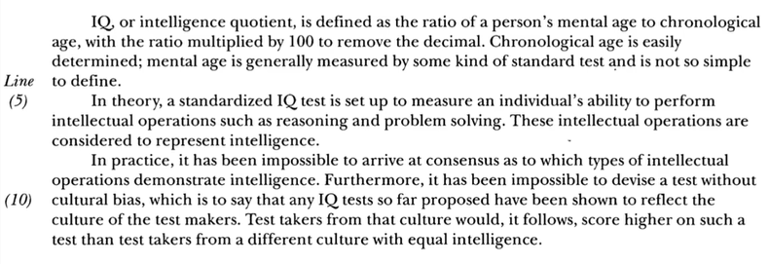
- What type of information is included in the first paragraph?
- An argument
- A definition
- An opinion
- A theory
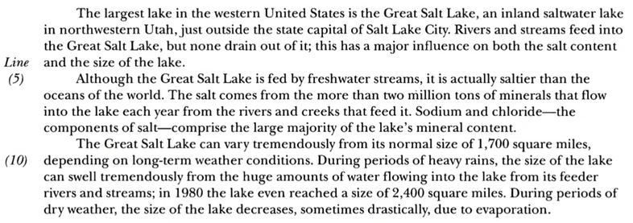
- How is the information in the passage organized?
- Two unusual characteristics of the Great Salt Lake are discussed
- Contrasting theories about the Great Salt Lake’s salt levels are presented
- The process by which the Great Salt Lake gets its salt is outlined
- The reasons for the variations in the Great Salt Lake’s size are given

EVALUASI SKILL 1 DAN 2
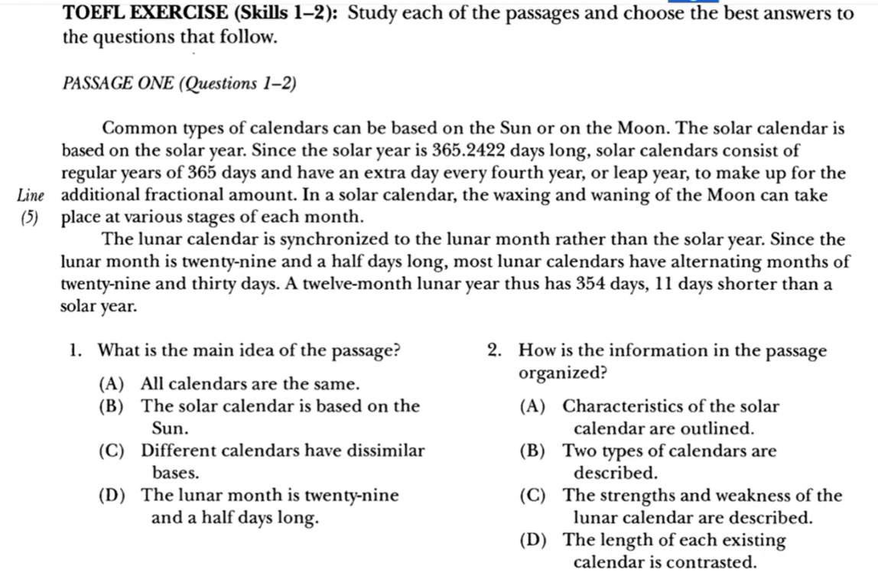
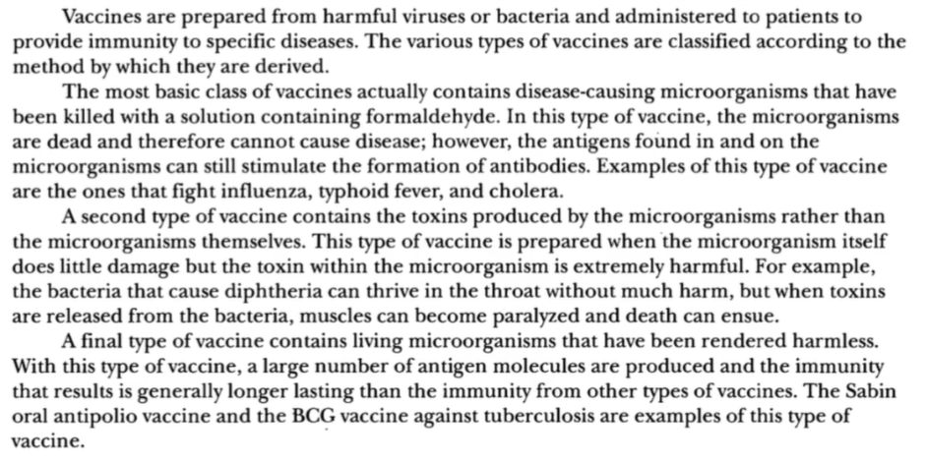
- Which of the following expresses the main idea of the passage?
- Vaccines provide immunity to specific disease
- Vaccines contain disease-causing microorganism
- Vaccines are derived in different ways
- New approaches in administering vaccines are being developed
- How many types of vaccines are presented in the passage?
- Two
- Three
- Four
- Five
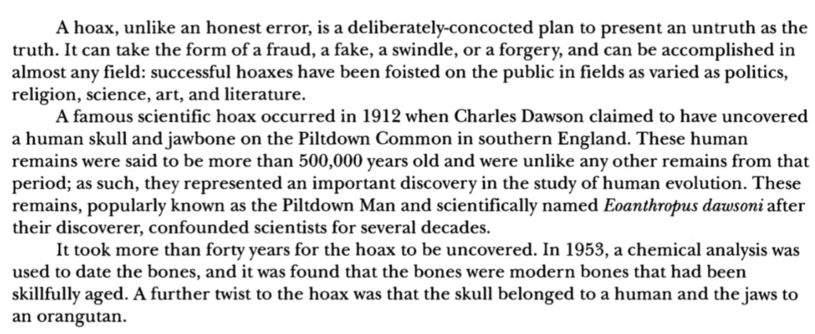
- The topic of this passage could be best described as?
- The Piltdown Man
- Charles Dawson’s discovery
- Eoanthropus dawsoni
- A definition and example of a hoax
- The author’s main point is that
- Various types of hoaxes have been perpetrated
- Charles Dawson discovered a human skull and jawbone
- Charles Dawson was not an honest man
- The human skull and jawbone were extremely old

